Student Name: Drishti Bhatia | UID: 25MCD10008
Branch: Master in Computer Applications (Data Science) | Section/Group: A
Semester: 2 | Date of Performance: 13-01-2026
Subject Name: Technical Training | Subject Code: 25CAP-652

Experiment No: 1.1

- Aim of the practical:
To design and implement a sample database system using DDL, DML, and DCL commands, including database creation, data manipulation, schema modification, and role-based access control to ensure data integrity and secure, read-only access for authorized users.

- S/W Requirement: Oracle Database Express Edition and PGAdmin.

- Objective:

To gain practical experience in implementing Data Definition Language (DDL), Data Manipulation Language (DML), and Data Control Language (DCL) operations in a real database environment. This will also include implementing role-based privileges to secure data.

- Code :

Creation of tables:

CREATE TABLE Department (

Dept_ID INT PRIMARY KEY,

Dept_Name VARCHAR(50) UNIQUE NOT NULL,

Location VARCHAR(50) NOT NULL

);

CREATE TABLE Employee (

Emp_ID INT PRIMARY KEY,

Emp_Name VARCHAR(50) NOT NULL,

Salary INT CHECK (Salary > 0),

Dept_ID INT REFERENCES Department(Dept_ID),

Email VARCHAR(100) UNIQUE );

CREATE TABLE Project (

Project_ID INT PRIMARY KEY,

Project_Name VARCHAR(50) NOT NULL,

Budget INT CHECK (Budget >= 10000),

Dept_ID INT REFERENCES Department(Dept_ID)

);

Inserting values into tables:

INSERT INTO Department VALUES

(1, 'HR', 'Mumbai'),

(2, 'IT', 'Pune'),

(3, 'Finance', 'Delhi');

INSERT INTO Employee VALUES

(101, 'Alice', 50000, 2, 'alice@org.com'),

(102, 'Bob', 45000, 1, 'bob@org.com'),

(103, 'Charlie', 60000, 2, 'charlie@org.com');

INSERT INTO Project VALUES

(201, 'Payroll System', 200000, 1),

(202, 'Web Application', 500000, 2);

Viewing tables:

SELECT * FROM Department;

SELECT * FROM Employee;

SELECT * FROM Project;

Updating table Employee:

UPDATE Employee

SET Salary = 55000

WHERE Emp_ID = 101;

Deleting from table:

DELETE FROM Department

WHERE Dept_ID = 3;

Creating role:

CREATE ROLE Analyst

With LOGIN PASSWORD 'analyst111'

Grant permissions:

GRANT SELECT ON Department TO Analyst;

GRANT SELECT ON Employee TO Analyst;

GRANT SELECT ON Project TO Analyst;

Revoke permissions:

REVOKE CREATE ON DATABASE tpp FROM Analyst;

Altering table:

ALTER TABLE Employee

ADD Phone_No VARCHAR(15);

ALTER TABLE Employee

ALTER COLUMN Emp_Name TYPE VARCHAR(100);

Deleting table:

DROP TABLE Project;

- Output:

Department table:

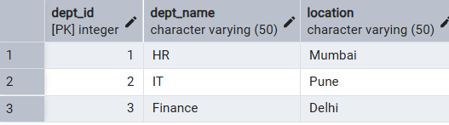

Employee table: 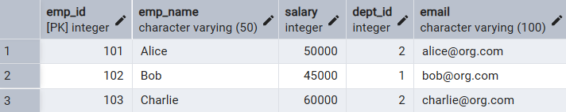

Project table:

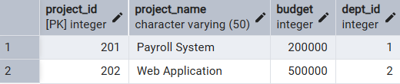

After update query:

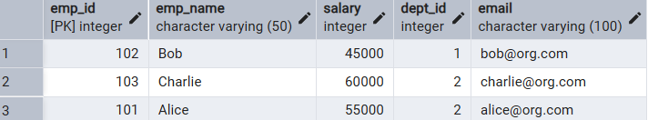

After deleting from table:

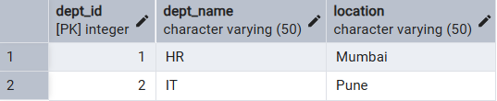

After alter query:

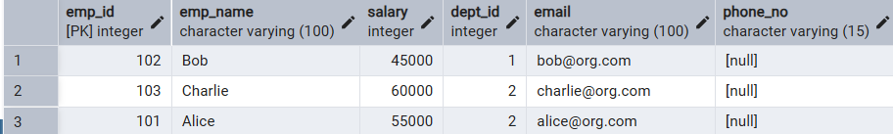

Revoke permissions:

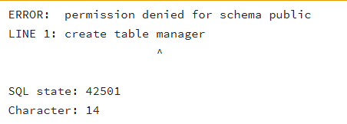
- Learning Outcomes:
- Understand how to design a relational database using multiple tables with proper relationships.
- Learn to apply constraints to maintain data integrity and consistency.
- Perform basic data manipulation operations such as INSERT, UPDATE, and DELETE.
- Implement database security by managing users, roles, and access privileges.

